**Programming Fundamentals**

**Lab 7**

**Submitted To:**

Mr. Dilshad Sabir

**Submitted By:**

Manaal Waseem

FA18-BCE-074

**In Lab:**

**Task 1:**

**Using the Notepad (the Windows text editor), save the program given in Code Listing 1 as a C file (test1.c). Then use the GNU CLI to compile the program and generate the intermediate files like, test1.i, test1.s, test1.o and finally test1.exe.**

**You will find the GNU Compiler in C:\Program Files\CodeBlocks\MinGW\Bin.**

**Hint: You will have to provide the complete path to source and destination files in double quotes (e.g. “Path\test1.c”).**

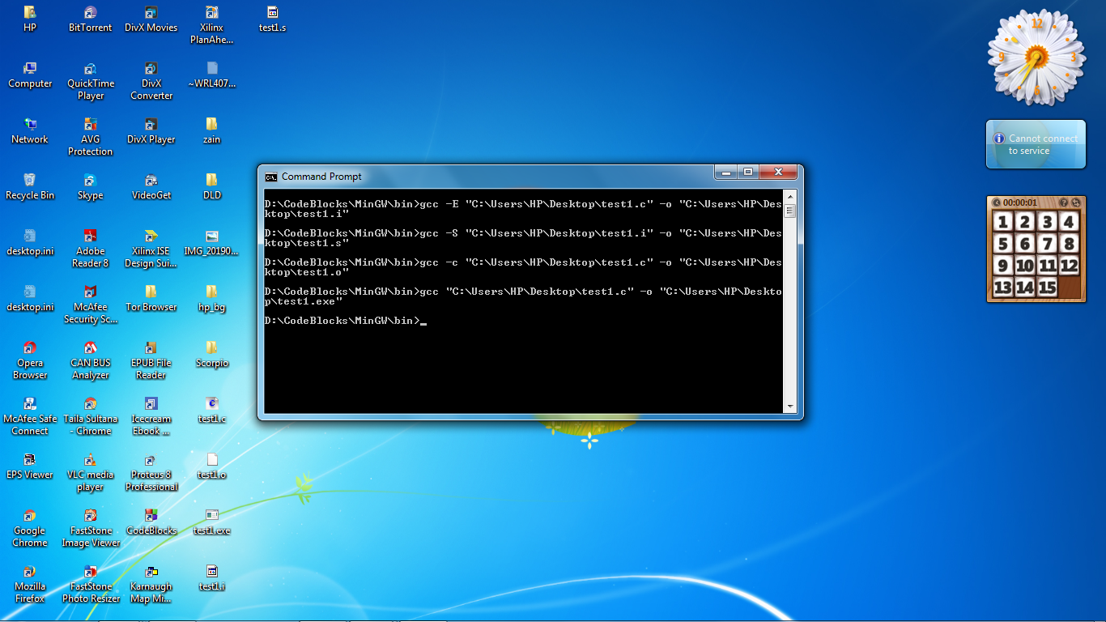

**Commands in Command Prompt**

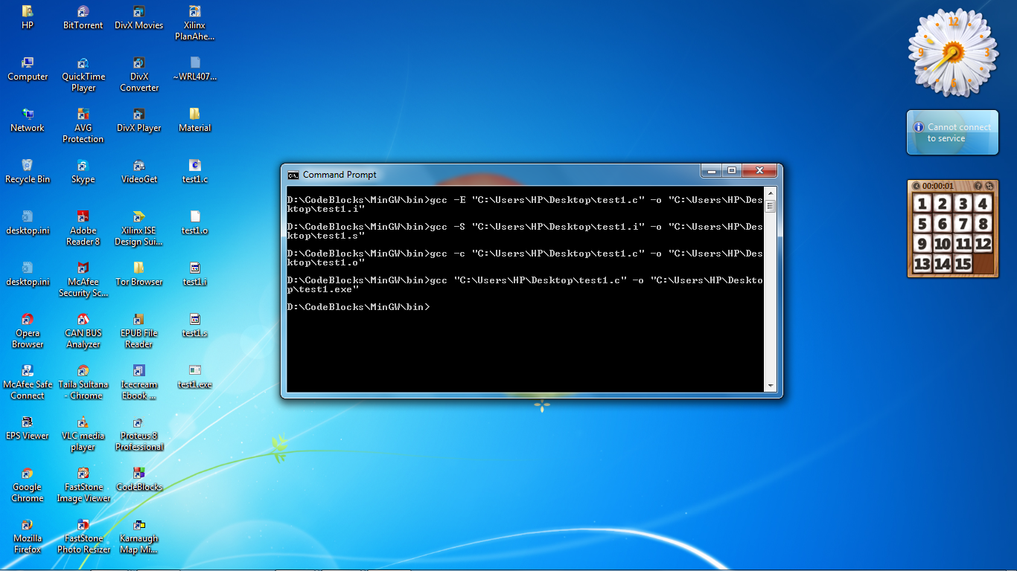

**Newly Created Files on Desktop**

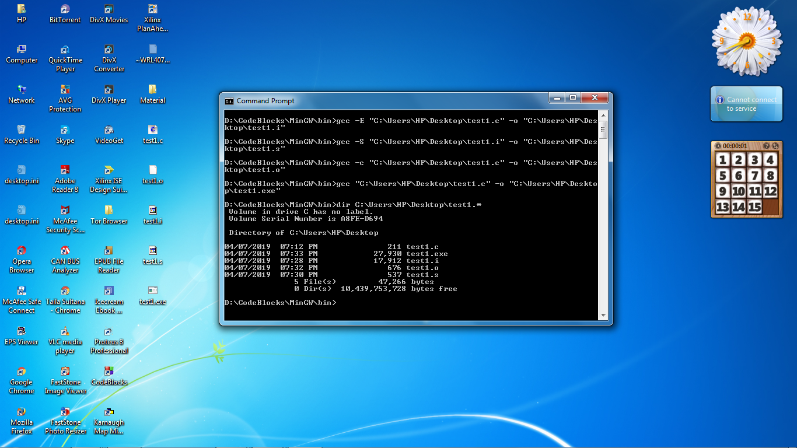

**Newly Created Files Being viewed in Directory through**

**Command Prompt**

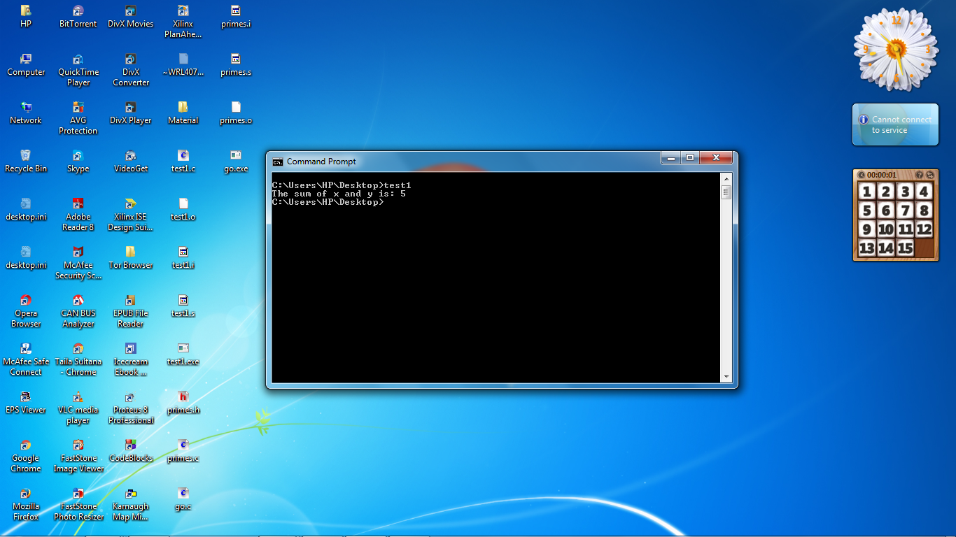

**Output**

**Task 2:**

**Using the Notepad (the Windows text editor), save the programs given in Code Listing 2, 3 and 4 as c/h files (primes.h, primes.c, and go.c). Then use the GNU CLI to compile the program and generate the intermediate files like, go.i, go.s, go.o and finally go.exe.**

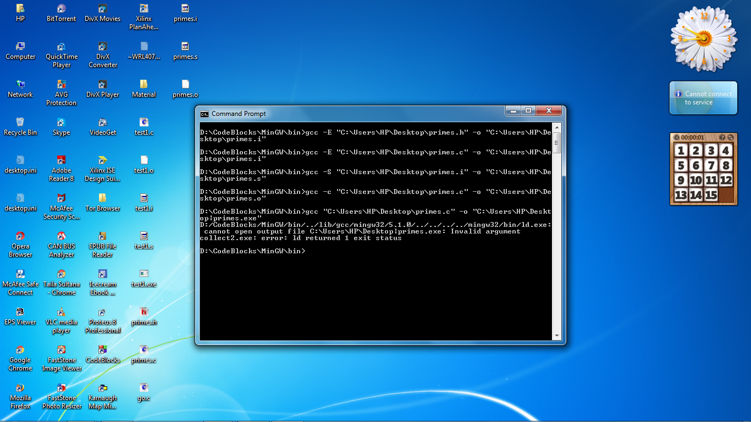**Commands in Command Prompt showing error**

**in an attempt to create .exe File**



**Newly Created Files except .exe File**

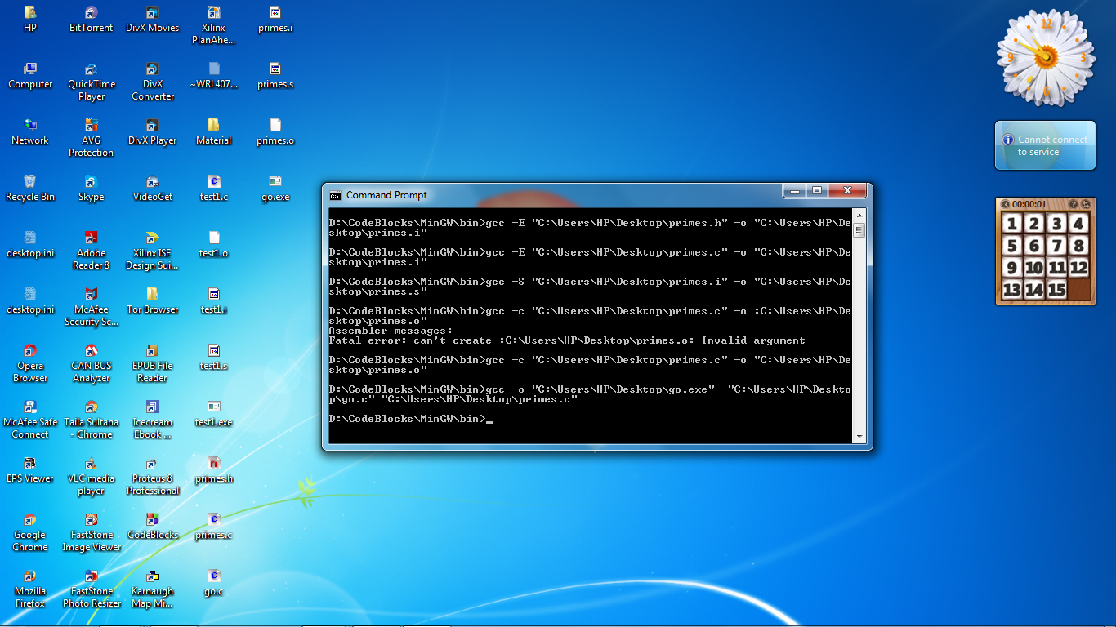

**Commands in Command Prompt after**

**successfully eradicating error**

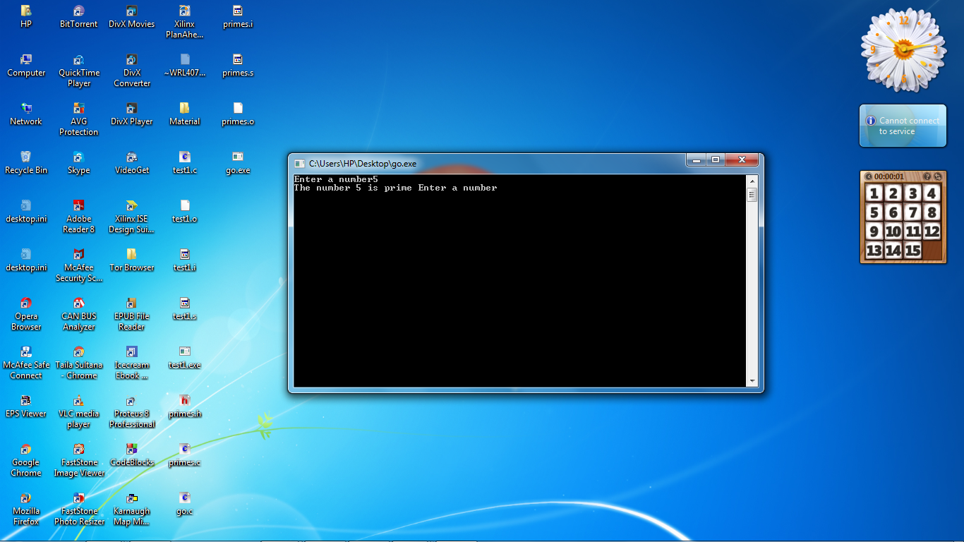

**Output**

**Post Lab:**

**Submit a hand written report on what difficulties you faced in the lab, what sources of information did you refer to to solve your problems, and what were the solutions you implemented.**

The in-lab task 1 was easily executed by following the instructions in the reading material. We copied the source code from the reading material to note pad and saved it with file extension **“.c”**. Then in Command Prompt we followed the step by step procedure to create files with extensions; **“.i”**, **“.s”**, **“.o”** and **“.exe”**. As far as second In-lab task 2 is concerned; first of all we saved the source code separately in three notepad documents, namely **“primes.h”**, **“primes.c”** and **“go.c”**. Then using the similar commands as in in-lab task 1, we successfully created files; **“primes.i”**, **“primes.s”** and **“primes.o”**. But command prompt gave error continuously while we attempted to create **“go.exe”** using command:

gcc “Path\test1.c” -o “Path\test1.exe”

I made loads of attempts and tried to eradicate the error. I also consulted the following links mentioned at the end of reading material:

1. <https://www.gribblelab.org/CBootCamp/12_Compiling_linking_Makefile_header_files.html>
2. <https://www.geeksforgeeks.org/compiling-a-c-program-behind-the-scenes/>
3. <https://www.gribblelab.org/CBootCamp/>

But still the problem didn’t solved. After wasting lots of time and digging deep we at last found the command to be executed actually; incidentally it was found in the commented section of the source code provided in the reading material.

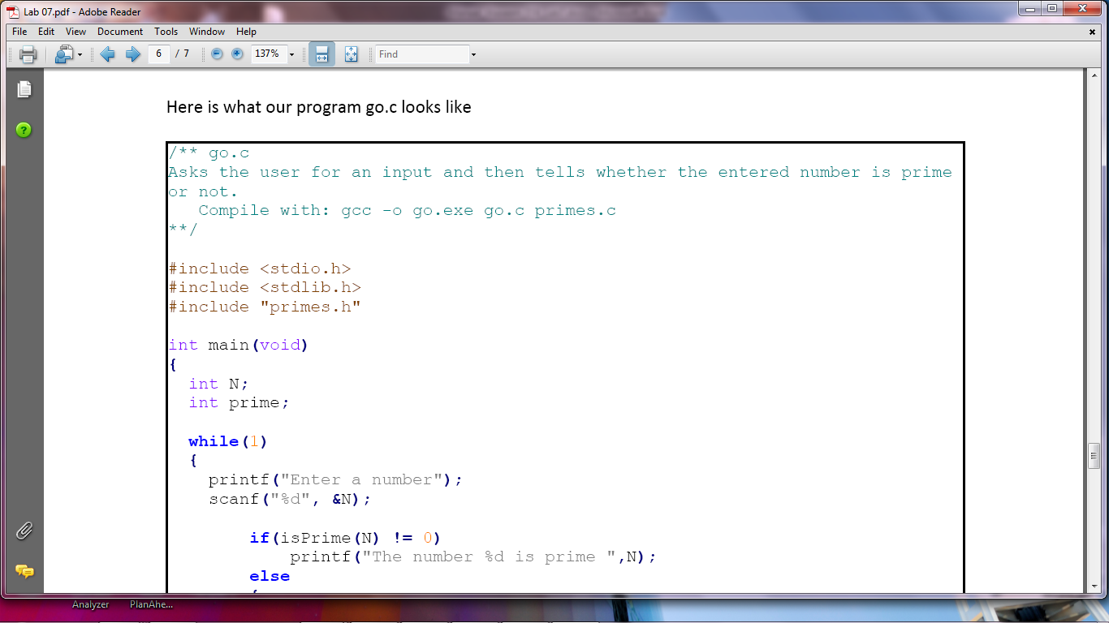

**Commented section**

So we finally ended up making the **“go.exe”** file successfully.

**Lesson Learnt:** Read each and every line of the reading material provided in lab with rapt attention.

**_______________________**

**THE END**